Specific Aims:
Dispersal is a key stage in the formation of Candida albicans biofilms but remains understudied. C. albicans is a polymorphic human commensal fungus with multiple yeast-form cellular states as well as hyphal and pseudohyphal states¹. Dispersal, or the production of planktonic yeast-form cells from biofilm hyphae, is the primary way in which biofilms disseminate². The formation of hyphae is well characterized in vitro, with the identification of many of the environmental stimuli, corresponding regulatory networks, and resulting cellular states and transcriptional signatures². However, when it comes to dispersal, only a few environmental stimuli and genetic regulators have been uncovered, without any full regulatory networks or fully understood methods of control³. Most studies were not performed in biologically relevant settings. Even for biofilm formation, recent work has shown genetic regulation to be context specific enough that many accepted results do not hold in vivo, indicating that more work with flexible models is needed⁴.
Using a range of growth conditions, I have demonstrated that dispersal is a distinct stage of biofilm development which generally coincides with the cessation of biofilm expansion and is regulated through extracellular signaling. I have also shown that there are distinct subpopulations of dispersed cells and that dispersed cells form biofilm more rapidly than cultured planktonic cells in fresh media while only cultured planktonic cells form biofilm in conditioned media. I aim to uncover the extracellular signaling molecule responsible for inducing dispersal and whether there is a single dispersal response or multiple pathways giving rise to distinct dispersal phenotypes. Finally, I aim to investigate how subpopulations of dispersed cells fit into C. albicans mutualism and pathogenesis with the human host. I hypothesize that dispersal is a response to environmental saturation regulated by an extracellular, stress-linked, quorum-sensing molecule resulting in multiple cell states which are optimized for some combination of colony formation, persistence, and the maintenance of genetic diversity.
Aim 1: Assay dispersed cell subpopulations for persistence, adhesion, and other traits to better understand their properties and potential role in the biofilm lifecycle.
Previous studies have shown dispersed cells to have increased virulence, adhesion, and proclivity to form biofilm^{3,8}. My preliminary results have identified two subpopulations of dispersed cells which form germ tubes at different rates and are identifiable using light microscopy. I will further characterize these subpopulations of dispersed cells by looking for further heterogeneity, placing them within the context of the many described yeast form cellular states, and more thoroughly analyzing their behavior in a range of settings.
Aim 2: Leverage omics along with genetic and environmental perturbation to uncover the signals and pathways regulating C. albicans dispersal.
I have found that media conditioned on dispersing biofilms promotes premature dispersal, breaking the otherwise persistent synchronization I have identified between dispersal and the cessation of biofilm expansion. I will use media fractionation to identify the causative molecule in addition to conditioning the media on C. albicans grown under multiple conditions to verify that this signaling is responsible for dispersal in all circumstances. I will also use the transcriptomic data we have generated and screen mutant lines for dispersal phenotypes to investigate the genetic regulation of this putative dispersal inducing molecule.
I will also investigate the regulation specifically of the different subpopulations of dispersed cells. I will verify that both cell types disperse directly rather than one differentiating into the other following dispersal. I will further assess both cell types for other relevant traits and their relative abundances following dispersal triggered by different environmental conditions.

Research Strategy:
Significance:
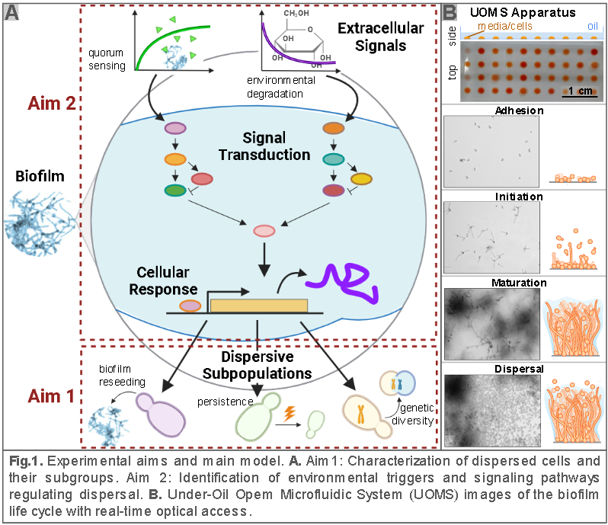
Candida albicans is a prevalent, generally commensal member of the human mycobiome carried by most people their entire lives⁵. Simultaneously, C. albicans is also a major opportunistic pathogen – in immunocompetent individuals this generally manifests in vulvovaginal (yeast infections) and cutaneous infections while in immunocompromised people, C. albicans can also cause superficial oral infections (thrush) or internal solid organ or bloodstream infections. 70-75% of people with vaginas will have at least one vulvovaginal C. albicans infection within their lifetime, the annual cost of candidiasis is estimated at over $4 billion in the U.S. alone, and nearly 1 million global deaths are attributed to candidiasis annually^{53,54,69}. Candida yeasts cause 80-90% of biofilm-associated invasive fungal infections and are a leading cause of healthcare associated bloodstream infections. Mortality rates average 40 %, and only three major classes of antifungals exist⁶. With the increasing use of device-based interventions, higher population of long-term immunocompromised people, and rising global temperatures, the incidence of Candida infections and antifungal resistance is rising⁷. While much of this is due to the increase in non-albicans Candida species, C. albicans infection remains the most prevalent and it is the best studied species, making it a useful model organism both as a primary health target and a representative of polymorphic opportunistic fungal pathogens. C. albicans’ pathogenesis is associated with a cycle of biofilm formation and dispersal, and its ability to invade a variety of host tissues while evading the immune system and treatment is in part due to its ability to switch between cellular states with distinct metabolic signatures, adhesins, and morphologies. Simultaneously, Candida cell state transition has been linked to functional immune and metabolic regulation^{11,12}. Thus, understanding the transitions between these states holds promise for treatment of pathology. While C. albicans hyphae are most associated with infection– in part due to their secretion of candidalysin, dispersal has been shown to be required for lethality of candidiasis in murine models, potentially in part since fungal infections spread primarily through dispersal^{3,9,10,51,52}. Dispersed cells are physiologically distinct from commensal planktonic cells and are primed for further infection⁸. While biofilm formation is well characterized, our understanding of dispersal is rudimentary due to technical challenges in isolating and quantifying dispersed cells^{13,14,15}. Cellular state is often ignored in microbiome studies, especially for eukaryotic microorganisms, since studies of microbial communities generally focus on bacteria and commonly only catalog organisms by DNA sequencing without accounting for the polymorphic nature of most microorganisms^{16,17}. I will address this through a thorough characterization of the regulation of dispersal and the resulting cellular populations (Fig. 1). By better understanding how to control transitions between cellular states and the significance of these states, we can find management strategies which avoid infection and encourage mutualism rather than relying on antifungals with limited efficacy and potentially harmful effects on host health and microbial balance ^{7,68}.
Approach:
Aim 1: Assay dispersed cell subpopulations for persistence, adhesion, and other relevant traits to better understand their role in the biofilm lifecycle.
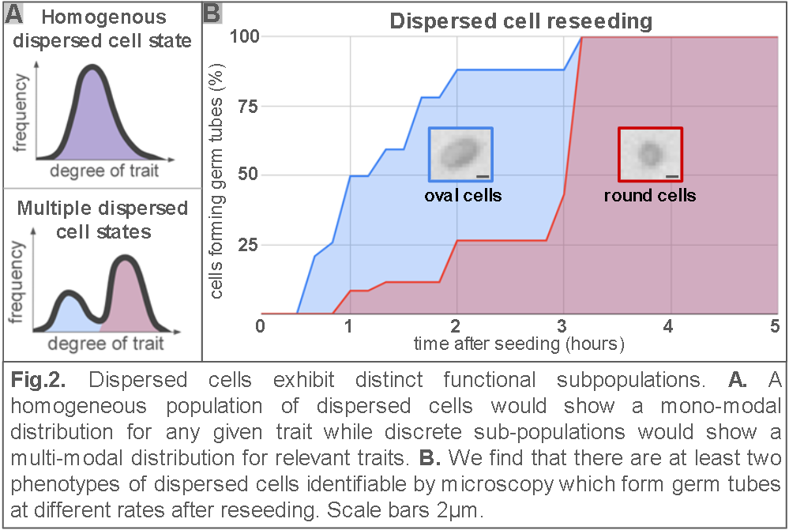
Dispersed cells have been identified as a distinct cell type, but only in comparison to planktonic cells grown in very different conditions to limit the formation of hyphae³. Limited analysis of dispersed cells has been performed, and there have been no efforts to match their properties to the many yeast-form cellular states C. albicans is known to assume. Understanding the phenotype and potential heterogeneity of dispersing cells could have major clinical impacts, especially if we could identify virulent and non-virulent subpopulations to target infection while minimally disrupting the microbiome. If certain dispersed cells are very persistent – challenging to kill – but these are not the most adherent cells – ready to attach to human epithelial or endothelial cells, then potentially they are not a major treatment priority.
Rationale: Dispersed cells have previously been described as having round and elongated phenotypes, with relative abundance correlating with environmental conditions⁸. I have similarly found distinct round and oval dispersed cells and have further found the oval cells form germ tubes more rapidly when replated in fresh media (Fig. 2). This functional difference and environmental regulation suggest that there are distinct subpopulations of dispersed cells which could potentially have implications for human health. Dispersed cells have been characterized only as a single population, and only in contrast to hyphae and yeast form cells grown in liquid medium, rather than the many C. albicans yeast-form cellular states. This represents a major gap in our ability to fit the process of dispersal into our greater knowledge of C. albicans biology and commensalism.
Model: I propose three likely overlapping models for the dispersed cell subpopulations. 1) Distinct cell types are a bet hedging strategy to account for environmental variation^{55,64}. 2) Distinct cell types are specialized to fulfill different rolls within the biofilm formation cycle⁵⁶. 3) Distinct cell types correspond to the already described yeast-form states C. albicans is known to take in other contexts¹.
Approach: To test the first model, I will reseed dispersed cells in a variety of environmental conditions including physiologically relevant combinations of pH, oxygenation, and nutrients. If dispersed cell heterogeneity provides bet hedging, I would expect different subgroups to have better survival depending on the niche in which they are placed.
To test the second model, I will assess the individual dispersed cells’ aptitude to perform various tasks which would likely increase the likelihood of the colony. I will perform established protocols to perform proliferation, adherence, colony formation, and immune and antifungal resistance assays to determine the degree and variability of these traits within dispersed cells and identify functional subpopulations^{8,71}. In addition to reproducing, forming new biofilms, and persisting, one could imagine that it would be desirable to increase genetic diversity amongst the tens of thousands dispersed cells produced per microliter³⁰. There are several pathways for increasing genetic or epigenetic diversity in C. albicans which have been shown in C. albicans or other fungi to increase antifungal resistance or niche adaptation. I will thus assess the propensity of dispersed cells to increase functional genetic diversity through RNAi^{27,57}, parameiosis^{28,29}, and aneuploidy^{58,59}. These processes have not been previously linked to dispersal, but the first two processes are reported in yeast-form rather than hyphal cells, while parameiosis could conceivably be benefitted by planktonic cells increasing likelihood of encountering yeast with a different genetic background³⁰. I will screen for RNAi activity via siRNA sequencing – followed up with comparative transcriptomics with Ago1 knock-out if preliminary results are promising, parameiosis via complementary tagging of two strains targeted for mating, and aneuploidy via sequencing, karyotyping, or loss of heterozygosity reporter strains^{27,72}.
Finally, I will test for overlap between dispersed cell subpopulations and known cell states through conventional approaches such as phloxine B staining, comparing our RNA-seq data for dispersed cells with available transcriptomic data to look for signatures of known cell states, and state specific fluorescent reporters. We will use Wh11 tagging to identify white cells, Op4 tagging to identify opaque cells, and Rfg1 tagging to identify pseudohyphae^{60,61}. I am currently working to identify suitable tags for other cell states. This is complicated slightly by the unusual transcriptional profile of dispersed cells, which we have found to express many genes thought to be hyphae specific.
Especially if we find interesting results in any of the above assays, we will perform single cell or subgroup enriched transcriptomics to assess subgroup specific transcriptional signatures.
Critical analysis: Many of the assays I intend to use are either endpoint assays or risk pushing the cells into a new cellular state. Thus, it will be very challenging to cluster traits – determine the overlap of traits within cell populations. For example, I might identify that a subset of the cells has increased antifungal resistance, and a subset has enhanced immune evasion, but determining if these subpopulations are the same, mutually exclusive, or partially overlapping will be a major hurdle since both assays kill or alter cellular state. To overcome this, I am imaging all experiments in the hopes of identifying visually identifiable phenotypes correlated with observed traits which. The two subtypes of dispersed cells with different rates of hyphal formation are a great example of this; they are visually distinguishable by shape. If I identify functional subgroups without any such identification, I will attempt to cluster traits by looking for correlated changes in trait frequency in response to changing conditions, since media conditions have been found to change the proportion of dispersed cell morphologies⁸. It is quite possible that I will find limited functional heterogeneity amongst these traits, but these assays will still provide a valuable and thorough characterization of dispersed cells. Alternately, if I find significant heterogeneity or even distinct subpopulations for these traits, there is the possibility that these findings will open the door to more targeted C. albicans therapies to specifically target cells with the highest risk for pathogenesis.
Aim 2: Leverage omics along with genetic and environmental perturbation to uncover the signals and pathways regulating C. albicans dispersal.
Dispersal has generally been treated simply as the downregulation of hyphal promoters rather than a distinct phase in the biofilm lifecycle worthy of investigation. As a result, while some genes or environmental conditions promoting or inhibiting dispersal have been identified, we have no complete pathways, nor have sufficient experiments been performed to gauge the generalizability of these results³. Dispersal has been shown to be required for lethality of candidiasis in murine models through control of C. albicans Pes1, Tup1, and Ume6^{9,19,62,63}. In addition, Ume6 based control of cellular state transitions was used to show their necessity for C. albicans derived rescue of the immunological issues facing germ-free mice¹¹. These findings highlight the importance of understanding the regulation of dispersal to provide potential underexploited targets for antifungals and to improve our understanding of the dynamics which push C. albicans towards mutualism or pathogenesis.
Aim 2.1: Investigate the signals sufficient and necessary to induce dispersal.
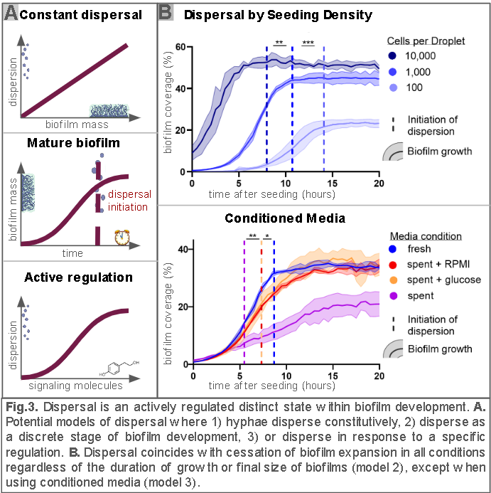
Rationale: Hyphae are thought to constitutively produce dispersed cells^{3,8}. However, my preliminary results suggest that dispersal is a distinct, regulated phenomenon as there is a clear time of initiation rather than a gradual increase in dispersed cells proportional to biofilm mass. I find dispersal initiates as the biofilm ceases expanding in nearly all conditions, indicating that dispersal is a function of mature biofilms. Changing factors from pH to glucose concentrations changes the rate and duration of biofilm growth, but dispersal stays synchronized with cessation of biofilm expansion. Conditioned media from a dispersing biofilm disrupts this synchronization, causing premature dispersal and implying that while dispersal is regulated as a defined step within the biofilm lifecycle, this regulation is mediated by extracellular signaling (Fig. 3).
Model: I hypothesize that this signaling is in response to environmental saturation. There could also be distinct quorum sensing and stress-based pathways. However, it is unlikely that either alone is necessary for inducing dispersal as dispersal is observed at variable concentrations of yeast, making it not simply a matter of quorum sensing and is observed under flow, making it unlikely to only be a response to inhospitable conditions unless it is very microenvironment based⁸. I further hypothesize that dispersal signaling occurs either through excreted metabolites or extracellular vesicles, the two most observed vehicles of C. albicans extracellular signaling^{20,21}.
Approach: I first tested if either farnesol or tyrosol could be responsible for the asynchronization since both are known C. albicans quorum sensing molecules involved in the regulation of yeast-form hyphae transitions, but neither replicated the phenotype of conditioned media in which dispersal initiated before the cessation of biofilm expansion^{22,65}. My next steps will be to identify what conditioning and what components of the conditioned media are sufficient to prompt dispersal without halting biofilm growth. I will compare media conditioned on dispersing biofilms, pre-dispersal biofilms, and planktonic cells along with conditioned media which has been stripped of proteins through proteinase K, stripped of extracellular vesicles through centrifugation, or stripped of DNA and RNA through nucleases. Depending on the results of these assays, I will further fractionate the relevant component by molecular size and use sequencing or mass spectrometry to identify candidate molecules²³. To test whether dispersal under flow is dependent on local microenvironmental conditions, I will grow a biofilm on a mesh so that fluid exchange is allowed from the bottom of the biofilm as well. If this does not delay the onset of dispersal, then likely a different mechanism is at play.
Critical analysis: It is possible that no single molecule is sufficient to cause the phenotype we witness with conditioned media, which could result in none of the assayed media components resulting in premature dispersal. In this case, I will combine components, following the same process as above until I arrive at candidate molecules for each part. It is also possible that there are multiple sufficient molecules, in which case more than one media component might cause dispersal. If this occurs, I will investigate each molecule separately. Once candidate molecules have been identified, I will attempt to use genetic knockout, chemical inhibition, and molecule addition to validate their roles. I will perform these validations under multiple conditions to gauge the generalizability of my results.
Aim 2.2: Identify mutants with a dispersal phenotype and use RNA transcriptomics to identify the regulatory circuitry which regulates and transduces the above signal for the cellular response of dispersal.
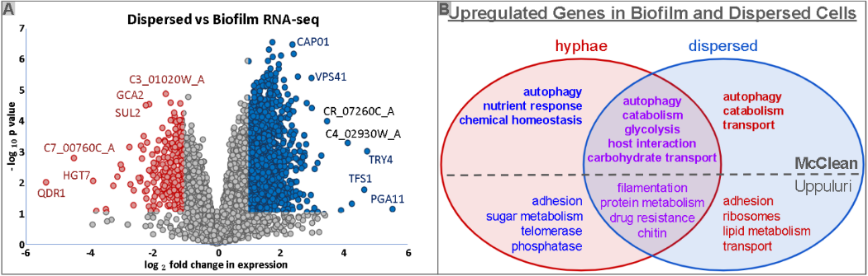
Rationale: Dispersal has been shown to be regulated in part by Rob1, Ume6, Hsp90, Nrg1, and Pes1^{3,24}. However, this is clearly not the whole picture, and no pathways leading all the way from external signals to cellular response have been uncovered as has been done for biofilm formation. Both my own analysis and that of Uppuluri et al has found the transcriptional profile of dispersed cells correlates more closely with the dispersing biofilm than with planktonic cells, even though there is very little overlap between my and Uppuluri’s results (Fig. 4)³. While this lack of reproducibility may be partially due to limitations in or differences between our experimental protocols, it also may have to do with the heterogeneity of dispersed cells investigated in Aim 1. Uppuluri observed that round and oval cell relative abundances depended upon media conditions, suggesting that there may be semi-independent regulation of the production of different dispersed cell subgroups⁸. I have also observed that within the UOMS, dispersed cells do not form germ tubes or replicate until they have been reseeded in fresh media, even though planktonic cells will form biofilm when seeded in conditioned media. On the other hand, dispersed cells form biofilm more rapidly than the planktonic cells in fresh media, suggesting that the inability to form hyphae in conditioned media is not due to a general inability to do so on the part of dispersed cells, but rather regulation to ensure they actually disperse. These results together suggest that there is still much more to be learned about C. albicans dispersal regulatory pathways and furthermore that they may have major therapeutic implications if for example dispersed cells could be kept from forming new biofilms or virulent cell types could be kept from dispersing in the first place.
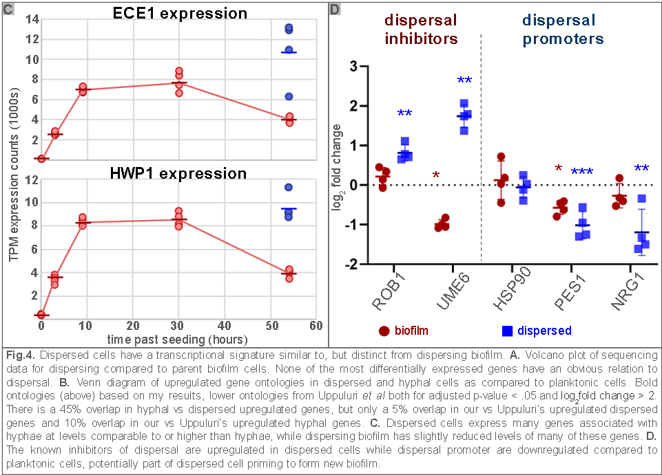
Model: I hypothesize that the regulation of dispersal is not simply the reverse of the regulatory pathways leading to hyphal development, due to the maintenance of hyphae associated transcriptional signatures in dispersed cells and the unique reseeding behavior of dispersed cells. I further hypothesize that all dispersal is regulated via a single master pathway, with secondary signaling determining dispersed cell fate.
Approach: Using UOMS, I can quantitatively and qualitatively screen the dispersal of many cell lines in parallel. This enables me to test a variety of transcription factor, extracellular vesicle related, and other potentially relevant mutants for dispersal phenotypes to identify machinery necessary to or otherwise affecting dispersal. This would include alterations to overall dispersal or a shifting of the proportion of dispersed cell subpopulations. I am also developing optogenetic transcription factor control for C. albicans. After initial screening using the GRACE library to temporally control gene expression in order to disentangle the effects on biofilm development from direct effects on dispersal, I will use optogenetic control of high priority genes to both spatially and reversibly control their expression and thus separate out locally effective from globally effective and permanently necessary from temporally necessary genes for dispersal^{25,70}. I will also look for more candidate pathways to investigate by performing similar screening while altering environmental conditions including oxygenation, pH, flow, and carbon source. I will also combine my and Uppuluri’s transcriptomics along with datasets not specific to dispersal to look for transcriptional networks and common motifs of upregulated gene promoter regions along with overlap with other cellular states and processes through weighted gene co-expression network analysis⁶⁶. Using available C. albicans epigenetic datasets, I will look for potential shared regulators of genes up or down regulated in dispersal. Our data include a time course with transcriptomic data from planktonic, three time points of pre-dispersal biofilm, dispersing biofilm, and dispersed cells, which I will use to better identify potential networks with the TiSA pipeline which clusters expression patterns along conditional and temporal axes to extract potential regulatory networks from low replicate, imperfect datasets²⁶. I will then validate regulatory networks using optogenetic control of involved genes as described above. Ideally single cell or subpopulation sorted transcriptomics can also be performed to distinguish the transcriptional signatures of dispersed cell subtypes and the biofilms giving rise to them, if I manage to identify any conditions where a biofilm produces only one dispersed cell type. Once I identify the dispersal signaling molecule in Aim 2.1, I will also repeat sequencing while treating with or inhibiting this molecule.
Critical analysis: While the temporal aspect of optogenetic control will enable me to parse the effects of biofilm and dispersal regulation, there is a major risk that redundant pathways will compensate for each other, masking potentially important genes in my knockout screen. However, many of these genes should be uncovered by the analysis of the transcriptional data, enabling me to identify places where multiple knockouts might be necessary. There is also the possibility that dispersed cells are indeed homogenous, but differentiate rapidly after dispersal, in which case there would likely be limited regulation of dispersed cell heterogeneity within the biofilm. This can be tested by more high-resolution microscopy and by removing and analyzing lateral buds before they disperse. There is also the possibility that much of the regulation is not transcriptional – C. albicans production of candidalysin is regulated in part by post-translational cleavage and many of the changes induced by farnesol exposure are due to direct farnesylation of proteins^{67,65}. However, these would still have transcriptional signatures, and by comparing against datasets analyzing such regulatory pathways, I should be able to identify similar patterns.
Timeline:
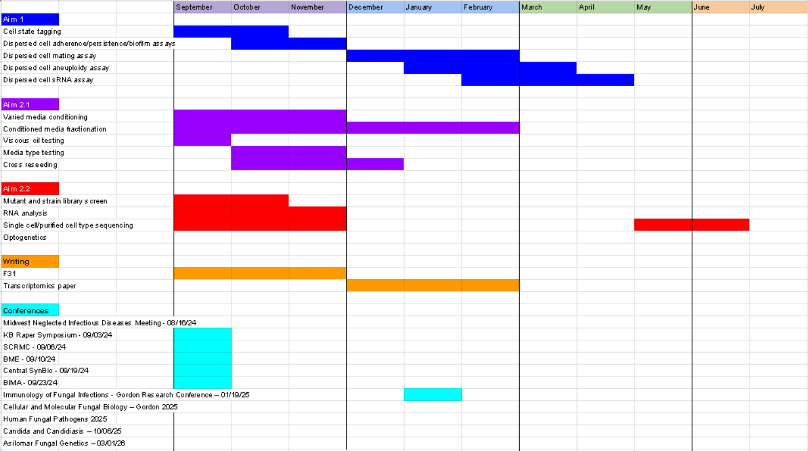
Bibliography:
- Noble SM, Gianetti BA, Witchley JN. Candida albicans cell-type switching and functional plasticity in the mammalian host. Nat Rev Microbiol. 2017 Feb;15(2):96-108.
- Gulati M, Nobile CJ. Candida albicans biofilms: development, regulation, and molecular mechanisms. Microbes Infect. 2016 May;18(5):310-21.
- Uppuluri P, Acosta Zaldívar M, Anderson MZ, Dunn MJ, Berman J, Lopez Ribot JL, Köhler JR. Candida albicans Dispersed Cells Are Developmentally Distinct from Biofilm and Planktonic Cells. mBio 2018. 9:10.1128.
- Wakade, R. S., Wellington, M., & Krysan, D. J. (2024). Temporal dynamics of Candida albicans morphogenesis and gene expression reveals distinctions between in vitro and in vivo filamentation. Msphere, 9(4), e00110-24.
- Romo JA, Kumamoto CA. On commensalism of Candida. Journal of Fungi. 2020 Jan 17;6(1):16.
- Pappas PG, Lionakis MS, Arendrup MC, Ostrosky-Zeichner L, Kullberg BJ. Invasive candidiasis. Nature Reviews Disease Primers. 2018 May 11;4(1):1-20.
- Pfaller MA. Epidemiology of candidiasis. Journal of Hospital Infection. 1995 Jun 1;30:329-38.
- Uppuluri P, Chaturvedi AK, Srinivasan A, Banerjee M, Ramasubramaniam AK, Köhler JR, Kadosh D, Lopez-Ribot JL. 2010. Dispersion as an important step in the Candida albicans biofilm developmental cycle. PLoS Pathog 6:e1000828.
- Bendel CM, Hess DJ, Garni RM, Henry-Stanley M, Wells CL. Comparative virulence of Candida albicans yeast and filamentous forms in orally and intravenously inoculated mice. Critical care medicine. 2003 Feb 1;31(2):501-7.
- Liang SH, Sircaik S, Dainis J, Kakade P, Penumutchu S, McDonough LD, Chen YH, Frazer C, Schille TB, Allert S, Elshafee O. The hyphal-specific toxin candidalysin promotes fungal gut commensalism. Nature. 2024 Mar 21;627(8004):620-7.
- Shao, T. Y., Haslam, D. B., Bennett, R. J., & Way, S. S. (2022). Friendly fungi: symbiosis with commensal Candida albicans. Trends in immunology, 43(9), 706-717.
- Round, J. (2024). Microbes with benefits: Neonatal microbes promote lasting metabolic health. MycoTalks, S4E4.
- Robbins N, Cowen LE. Roles of Hsp90 in Candida albicans morphogenesis and virulence. Current Opinion in Microbiology. 2023 Oct 1;75:102351.
- Gulati M, Nobile CJ. Candida albicans biofilms: development, regulation, and molecular mechanisms. Microbes Infect. 2016 May;18(5):310-21.
- Daniels KJ, Park YN, Srikantha T, Pujol C, Soll DR. Impact of environmental conditions on the form and function of Candida albicans biofilms. Eukaryotic cell. 2013 Oct;12(10):1389-402.
- Bokulich NA, Ziemski M, Robeson II MS, Kaehler BD. Measuring the microbiome: Best practices for developing and benchmarking microbiomics methods. Computational and Structural Biotechnology Journal. 2020 Jan 1;18:4048-62.
- Debroas D, Domaizon I, Humbert JF, Jardillier L, Lepère C, Oudart A, Taïb N. Overview of freshwater microbial eukaryotes diversity: a first analysis of publicly available metabarcoding data. FEMS Microbiology Ecology. 2017 Apr;93(4):fix023.
- Li C, McCrone S, Warrick JW, Andes DR, Hite Z, Volk CF, Rose WE, Beebe DJ. Application of under-oil open microfluidic systems for rapid phenotypic antimicrobial susceptibility testing. medRxiv. 2022 Jun 27:2022-06.
- Wall G, Montelongo-Jauregui D, Vidal Bonifacio B, Lopez-Ribot JL, Uppuluri P. Candida albicans biofilm growth and dispersal: contributions to pathogenesis. Curr Opin Microbiol. 2019 Dec;52:1-6.
- Han, T. L., Cannon, R. D., & Villas-Bôas, S. G. (2011). The metabolic basis of Candida albicans morphogenesis and quorum sensing. Fungal Genetics and Biology, 48(8), 747-763.
- Honorato, Leandro, Joana Feital Demetrio de Araujo, Cameron C. Ellis, Alicia Corbellini Piffer, Yan Pereira, Susana Frases, Glauber Ribeiro de Sousa Araújo et al. "Extracellular vesicles regulate biofilm formation and yeast-to-hypha differentiation in Candida albicans." MBio 13, no. 3 (2022): e00301-22.
- Finkel JS, Mitchell AP. Genetic control of Candida albicans biofilm development. Nature Reviews Microbiology. 2011 Feb;9(2):109-18.
- Xu XL, Lee RT, Fang HM, Wang YM, Li R, Zou H, Zhu Y, Wang Y. Bacterial peptidoglycan triggers Candida albicans hyphal growth by directly activating the adenylyl cyclase Cyr1p. Cell host & microbe. 2008 Jul 17;4(1):28-39.
- Robbins N, Uppuluri P, Nett J, Rajendran R, Ramage G, Lopez-Ribot JL, Andes D, Cowen LE. Hsp90 governs dispersion and drug resistance of fungal biofilms. PLoS pathogens. 2011 Sep 8;7(9):e1002257.
- An-Adirekkun JM, Stewart CJ, Geller SH, Patel MT, Melendez J, Oakes BL, Noyes MB, McClean MN. A yeast optogenetic toolkit (yOTK) for gene expression control in Saccharomyces cerevisiae. Biotechnol Bioeng. 2020 Mar;117(3):886-893.
- Lefol Y, Korfage T, Mjelle R, Prebensen C, Lüders T, Müller B, Krokan H, Sarno A, Alsøe L, CONSORTIUM LEMONAID, Berdal JE. TiSA: TimeSeriesAnalysis—a pipeline for the analysis of longitudinal transcriptomics data. NAR Genomics and Bioinformatics. 2023 Mar 1;5(1):lqad020.
- Iracane E, Arias-Sardá C, Maufrais C, Ene IV, d’Enfert C, Buscaino A. Identification of an active RNAi pathway in Candida albicans. Proceedings of the National Academy of Sciences. 2024 Apr 23;121(17):e2315926121.
- Lockhart SR, Daniels KJ, Zhao R, Wessels D, Soll DR. Cell biology of mating in Candida albicans. Eukaryotic cell. 2003 Feb;2(1):49-61.
- Scaduto CM, Kabrawala S, Thomson GJ, Scheving W, Ly A, Anderson MZ, Whiteway M, Bennett RJ. Epigenetic control of pheromone MAPK signaling determines sexual fecundity in Candida albicans. Proceedings of the National Academy of Sciences. 2017 Dec 26;114(52):13780-5.
- Crow JF. Advantages of sexual reproduction. Developmental genetics. 1994;15(3):205-13.
- Fan D, Coughlin LA, Neubauer MM, Kim J, Kim MS, Zhan X, Simms-Waldrip TR, Xie Y, Hooper LV, Koh AY. Activation of HIF-1α and LL-37 by commensal bacteria inhibits Candida albicans colonization. Nature medicine. 2015 Jul;21(7):808-14.
- Forche A, Solis NV, Swidergall M, Thomas R, Guyer A, Beach A, Cromie GA, Le GT, Lowell E, Pavelka N, Berman J. Selection of Candida albicans trisomy during oropharyngeal infection results in a commensal-like phenotype. PLoS genetics. 2019 May 15;15(5):e1008137.
- Bachtiar EW, Bachtiar BM. Effect of cell‐free spent media prepared from Aggregatibacter actinomycetemcomitans on the growth of Candida albicans and Streptococcus mutans in co‐species biofilms. European Journal of Oral Sciences. 2020 Oct;128(5):395-404.
- Bachtiar EW, Bachtiar BM, Jarosz LM, Amir LR, Sunarto H, Ganin H, Meijler MM, Krom BP. AI-2 of Aggregatibacter actinomycetemcomitans inhibits Candida albicans biofilm formation. Frontiers in Cellular and Infection Microbiology. 2014 Jul 21;4:94.
- Bor B, Cen L, Agnello M, Shi W, He X. Morphological and physiological changes induced by contact-dependent interaction between Candida albicans and Fusobacterium nucleatum. Scientific reports. 2016 Jun 14;6(1):27956.
- Morse DJ, Wilson MJ, Wei X, Bradshaw DJ, Lewis MA, Williams DW. Modulation of Candida albicans virulence in in vitro biofilms by oral bacteria. Letters in applied microbiology. 2019 Apr 1;68(4):337-43.
- Holcombe LJ, McAlester G, Munro CA, Enjalbert B, Brown AJ, Gow NA, Ding C, Butler G, O'Gara F, Morrissey JP. Pseudomonas aeruginosa secreted factors impair biofilm development in Candida albicans. Microbiology. 2010 May;156(5):1476-86.
- Kim Y, Mylonakis E. Killing of Candida albicans filaments by Salmonella enterica serovar Typhimurium is mediated by sopB effectors, parts of a type III secretion system. Eukaryotic Cell. 2011 Jun;10(6):782-90.
- Zangl I, Pap IJ, Aspöck C, Schüller C. The role of Lactobacillus species in the control of Candida via biotrophic interactions. Microbial Cell. 2020 Jan 1;7(1):1.
- Graham CE, Cruz MR, Garsin DA, Lorenz MC. Enterococcus faecalis bacteriocin EntV inhibits hyphal morphogenesis, biofilm formation, and virulence of Candida albicans. Proceedings of the National Academy of Sciences. 2017 Apr 25;114(17):4507-12.
- Alshanta OA, Albashaireh K, McKloud E, Delaney C, Kean R, McLean W, Ramage G. Candida albicans and Enterococcus faecalis biofilm frenemies: When the relationship sours. Biofilm. 2022 Dec 1;4:100072.
- Bamford CV, d'Mello A, Nobbs AH, Dutton LC, Vickerman MM, Jenkinson HF. Streptococcus gordonii modulates Candida albicans biofilm formation through intergeneric communication. Infection and immunity. 2009 Sep;77(9):3696-704.
- Fox EP, Cowley ES, Nobile CJ, Hartooni N, Newman DK, Johnson AD. Anaerobic bacteria grow within Candida albicans biofilms and induce biofilm formation in suspension cultures. Current biology. 2014 Oct 20;24(20):2411-6.
- Cheong JA, Johnson CJ, Wan H, Liu A, Kernien JF, Gibson AL, Nett JE, Kalan LR. Priority effects dictate community structure and alter virulence of fungal-bacterial biofilms. The ISME Journal. 2021 Jul;15(7):2012-27.
- Yapar N. Epidemiology and risk factors for invasive candidiasis. Therapeutics and clinical risk management. 2014 Feb 13:95-105.
- Li XV, Leonardi I, Putzel GG, Semon A, Fiers WD, Kusakabe T, Lin WY, Gao IH, Doron I, Gutierrez-Guerrero A, DeCelie MB. Immune regulation by fungal strain diversity in inflammatory bowel disease. Nature. 2022 Mar 24;603(7902):672-8.
- Tao L, Du H, Guan G, Dai Y, Nobile CJ, Liang W, Cao C, Zhang Q, Zhong J, Huang G. Discovery of a “white-gray-opaque” tristable phenotypic switching system in Candida albicans: roles of non-genetic diversity in host adaptation. PLoS biology. 2014 Apr 1;12(4):e1001830.
- Xie J, Tao L, Nobile CJ, Tong Y, Guan G, Sun Y, Cao C, Hernday AD, Johnson AD, Zhang L, Bai FY. White-opaque switching in natural MTL a/α isolates of Candida albicans: evolutionary implications for roles in host adaptation, pathogenesis, and sex. PLoS biology. 2013 Mar 26;11(3):e1001525.
- Pande K, Chen C, Noble SM. Passage through the mammalian gut triggers a phenotypic switch that promotes Candida albicans commensalism. Nature genetics. 2013 Sep;45(9):1088-91.
- Peters BM, Palmer GE, Nash AK, Lilly EA, Fidel Jr PL, Noverr MC. Fungal morphogenetic pathways are required for the hallmark inflammatory response during Candida albicans vaginitis. Infection and immunity. 2014 Feb;82(2):532-43.
- Lo HJ, Köhler JR, DiDomenico B, Loebenberg D, Cacciapuoti A, Fink GR. Nonfilamentous C. albicans mutants are avirulent. Cell. 1997 Sep 5;90(5):939-49.
- Braun BR, Head WS, Wang MX, Johnson AD. Identification and characterization of TUP1-regulated genes in Candida albicans. Genetics. 2000 Sep 1;156(1):31-44.
- Sobel JD. Recurrent vulvovaginal candidiasis. American journal of obstetrics and gynecology. 2016 Jan 1;214(1):15-21.
- Benedict K, Whitham HK, Jackson BR. Economic burden of fungal diseases in the United States. Open Forum Infectious Diseases 2022 Apr 1 (Vol. 9, No. 4, p. ofac097). US: Oxford University Press.
- Charpentier A, Anand M, Bauch CT. Variable offspring size as an adaptation to environmental heterogeneity in a clonal plant species: integrating experimental and modelling approaches. Journal of ecology. 2012 Jan 1:184-95.
- Holbrook CT, Kukuk PF, Fewell JH. Increased group size promotes task specialization in a normally solitary halictine bee. Behaviour. 2013 Jan 1;150(12):1449-66.
- Cánovas-Márquez JT, Navarro-Mendoza MI, Pérez-Arques C, Lax C, Tahiri G, Pérez-Ruiz JA, Lorenzo-Gutiérrez D, Calo S, López-García S, Navarro E, Nicolás FE. Role of the non-canonical rnai pathway in the antifungal resistance and virulence of Mucorales. Genes. 2021 Apr 17;12(4):586.
- Mba IE, Nweze EI, Eze EA, Anyaegbunam ZK. Genome plasticity in Candida albicans: A cutting-edge strategy for evolution, adaptation, and survival. Infection, Genetics and Evolution. 2022 Apr 1;99:105256.
- Kakade P, Sircaik S, Maufrais C, Ene IV, Bennett RJ. Aneuploidy and gene dosage regulate filamentation and host colonization by Candida albicans. Proceedings of the National Academy of Sciences. 2023 Mar 14;120(11):e2218163120.
- Si H, Hernday AD, Hirakawa MP, Johnson AD, Bennett RJ. Candida albicans white and opaque cells undergo distinct programs of filamentous growth. PLoS pathogens. 2013 Mar 7;9(3):e1003210.
- Cleary IA, Mulabagal P, Reinhard SM, Yadev NP, Murdoch C, Thornhill MH, Lazzell AL, Monteagudo C, Thomas DP, Saville SP. Pseudohyphal regulation by the transcription factor Rfg1p in Candida albicans. Eukaryotic Cell. 2010 Sep;9(9):1363-73.
- Shen J, Cowen LE, Griffin AM, Chan L, Köhler JR. The Candida albicans pescadillo homolog is required for normal hypha-to-yeast morphogenesis and yeast proliferation. Proceedings of the National Academy of Sciences. 2008 Dec 30;105(52):20918-23.
- Carlisle PL, Banerjee M, Lazzell A, Monteagudo C, López-Ribot JL, Kadosh D. Expression levels of a filament-specific transcriptional regulator are sufficient to determine Candida albicans morphology and virulence. Proceedings of the National Academy of Sciences. 2009 Jan 13;106(2):599-604.
- Starrfelt J, Kokko H. Bet‐hedging—a triple trade‐off between means, variances and correlations. Biological Reviews. 2012 Aug;87(3):742-55.
- Nickerson KW, Gutzmann DJ, Boone CH, Pathirana RU, Atkin AL. Physiological adventures in Candida albicans: farnesol and ubiquinones. Microbiology and Molecular Biology Reviews. 2024 Mar 27;88(1):e00081-22.
- Burke EE, Chenoweth JG, Shin JH, Collado-Torres L, Kim SK, Micali N, Wang Y, Colantuoni C, Straub RE, Hoeppner DJ, Chen HY. Dissecting transcriptomic signatures of neuronal differentiation and maturation using iPSCs. Nature communications. 2020 Jan 23;11(1):462.
- Richardson JP, Mogavero S, Moyes DL, Blagojevic M, Krüger T, Verma AH, Coleman BM, De La Cruz Diaz J, Schulz D, Ponde NO, Carrano G. Processing of Candida albicans Ece1p is critical for candidalysin maturation and fungal virulence. MBio. 2018 Mar 7;9(1):10-128.
- Houšť J, Spížek J, Havlíček V. Antifungal drugs. Metabolites. 2020 Mar 12;10(3):106.
- Denning DW. Global incidence and mortality of severe fungal disease. The Lancet Infectious Diseases. 2024 Jan 12.
- Roemer T, Jiang B, Davison J, Ketela T, Veillette K, Breton A, Tandia F, Linteau A, Sillaots S, Marta C, Martel N. Large‐scale essential gene identification in Candida albicans and applications to antifungal drug discovery. Molecular microbiology. 2003 Oct;50(1):167-81.
- Klepser ME, Wolfe EJ, Jones RN, Nightingale CH, Pfaller MA. Antifungal pharmacodynamic characteristics of fluconazole and amphotericin B tested against Candida albicans. Antimicrobial Agents and Chemotherapy. 1997 Jun;41(6):1392-5.
- Marton TB. Loss of heterozygosity: its impact on generating and shaping genetic variations in human fungal pathogen candida albicans (Doctoral dissertation, Université Paris Cité).

